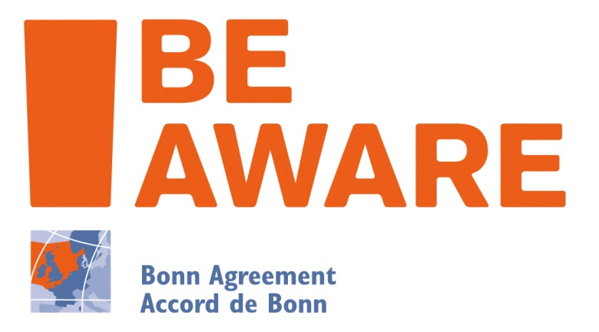 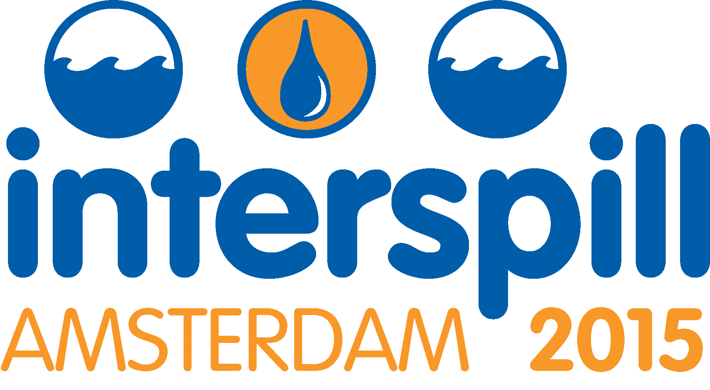

The BE-AWARE Project: Assessing the Most Effective Future Oil Pollution Risk Reduction and Response Measures

John Mouat, Deputy Secretary, Bonn Agreement

Abstract

The competition for space in the Greater North Sea and its approaches continues to grow year on year. The area contains some of the busiest shipping lanes in the world and is also a major oil and gas production area. However, in recent years there have been new demands for space such as the huge increase in the planning and installation of offshore wind farms. International targets to increase the coverage of marine protected areas have also reduced potential for development in sensitive areas and emerging uses, such as other marine renewables, have the potential to use additional space.

Therefore in order to reduce the risk of spills and their impact on the environment the Bonn Agreement BE-AWARE I and II projects aim to identify the most effective future risk reduction and response measures. Firstly by identifying areas at increased risk of accidents and the potential for spills in those areas, both now and in 2020, and secondly by modelling the out flow of oil for 10 different risk reducing and response scenarios. The results will then be combined with an environmental and socioeconomic vulnerability analysis of the area to assess the impact of the different scenarios allowing the Bonn Agreement Contracting Parties to adopt sub regional risk management conclusions.

The BE-AWARE project ran from January 2013 until December 2014 and the BE-AWARE II Project runs from December 2013 until November 2015 and both have been part funded by the EU Civil Protection Mechanism.

Introduction

The “Bonn Agreement: Area-Wide Assessment of Risk Evaluations” (BE-AWARE) project is the first area-wide risk assessment of marine pollution in the Greater North Sea and its wider approaches using a common methodology. The need for the risk assessment was agreed by Bonn Agreement Ministers, in the 2010 Dublin Declaration, given the increasing competition for space in the Greater North Sea and its approaches from shipping, oil and gas production, offshore renewable energy, as well as other emerging uses. The ultimate aim of the project is to identify the most effective and efficient risk reducing and response scenarios for 2020 to allow the Bonn Agreement Contracting Parties to develop risk management conclusions for the project sub regions. For administrative and financial reasons the project was split into two separate sections, however they are both integral parts of the overall process. BE-AWARE I, which ran from 2011-2013, enabled the pollution risk to be mapped and compared in a systematic way and BE-AWARE II, which runs from 2013-2015, will assess ten risk reducing and response scenarios and develop sub regional risk management conclusions. Both projects were co-financed by the European Union Civil Protection Mechanism and were led by the Bonn Agreement Secretariat with participation from the Contracting Parties and support from sub-contractors COWI and MARIN (BE-AWARE I only).

BE-AWARE I

The overall objective of BE-AWARE I was to gain a better understanding of the regional and sub-regional risk of accidents and the potential for marine pollution events in the Greater North Sea and its approaches. This objective was achieved by focusing on the risk of accidents and the potential for spills of oil and hazardous and noxious substances (HNS) from shipping. The risks derived from collisions with offshore installations (both wind farms and oil and gas installations) and from spills from installations themselves, were also included. As a discrete task, a regionally specific methodology for environmental and socioeconomic vulnerability analysis was also developed.

The methodology used was similar to that used in the BRISK Project undertaken in the HELCOM maritime area to calculate the risk and magnitude of spills. Analysis was undertaken for both 2011, the baseline year for the project, and for 2020, taking into consideration the expected changes in traffic routing and intensities and maritime uses. The methodology was adapted for conditions in the greater North Sea and was adopted in the project Methodology Note. This included defining the key parameters to be taken into consideration, such as: Hazard identification; Ship traffic; Classification of oil; Oil transport model; Traffic prognosis; Frequency and quantity of oil spills; Oil spills related to offshore installations and Qualitative analysis of HNS risks.

The models used a considerable amount of data, including accident statistics, automatic identification system (AIS) data, cargo data, risk-reducing measures, locations of fixed objects, etc. In order to collect a standard set of data for the whole Bonn Agreement area, a Data Collection Note was developed, outlining the data types and formats required from the relevant Contracting Parties.

AIS data for 2011 was provided by the Danish Maritime Authority. Detailed information on oil cargo at ship level was supplied by Mongstad (Norway), Hamburg (Germany), Rotterdam (Netherlands) and Antwerp (Belgium). This was used in the cargo model, allowing an increased level of accuracy. Rotterdam and Antwerp also provided detailed information on HNS shipments which was used in the qualitative HNS analysis.

The ship traffic model, developed by BE-AWARE, was based on the AIS data. From the intensity of the ship traffic a route net was developed that described the primary sailing routes and the number of vessels on those routes. This was then used to develop a traffic model that was a database of identified route passages, including direction and vessel characteristics. The database provided traffic data for the calculation of accident and spill frequencies, which were dependent upon the traffic, its volume and composition.



**Figure 1: Oil and chemical tanker movements mapped on the project route net.**

Using individual vessel information from the World Shipping Encyclopaedia, the model was able to estimate the consequences of an accident, based on the vessel characteristics. This was then combined with the cargo model, which described the probability of a certain ship type and ship size sailing on a specific route being loaded with a certain type of cargo. This used information that included ships routes, lists of substances and port data.

The major modification of the methodology for North Sea conditions was the inclusion of the spill risks from collisions with offshore gas and oil installations and offshore wind farms. The assessment therefore modelled several types of spills: spills from ships colliding with platforms or renewable installations; spills from platforms resulting from collisions with ships; and spills from oil platforms resulting from other damage. For oil platforms, risk calculations were related to daily operations and to risks such as blow-outs (noting the infrequent occurrence of these) with distinctions made between normal and high pressure, high temperature wells.

The ultimate results for risks of spills for 2011 and 2020 scenarios were then obtained by undertaking a further integrated analysis to take into account existing and intended (by 2020) Risk Reduction Measures (RRMs) such as pilotage, surveillance, (VTS), obligatory routing (TSS), emergency towing, etc.

Sensitivity analysis and vulnerability mapping

In addition to the above modelling work, BE-AWARE prepared the ground for later projects developing a simple, qualitative and commonly acceptable environmental and socioeconomic sensitivity analysis methodology. This was done via expert workshops and resulted in a BE-AWARE Environmental and Socioeconomic Sensitivity Mapping approach. The common sensitivity mapping approach contained three distinct steps: STEP 1 – The identification of sensitive ecological and socio-economic features; STEP 2 – The vulnerability assessment and ranking of these features, based on a set of objective criteria and resulting in a seasonal vulnerability score for each feature: and STEP 3 – The total (seasonal) vulnerability mapping.

Qualitative analysis of HNS spill risk

Another key pollution risk in the Greater North Sea is spills of hazardous and noxious substances (HNS) for which the project produced a qualitative analysis of this risk. This was because less information was available on the more diverse and complex HNS shipping activity, combined with very different outcomes from spills of different substances into the sea. The project was however able to obtain data for the ports of Rotterdam and Antwerp at the level of detail required for in-depth analysis. The analysis focused on categorising the different hazards posed by the substances in terms of how they react when released in an accident, their risk to public health and their risk to the environment. To the extent possible, the likelihood that HNS cargo was on-board a ship involved in an accident was also modelled using the SAMSON model. It was nevertheless recognised that there were shortcomings with the modelling, particularly that more local trade patterns of HNS were not captured by the analysis.

BE-AWARE I Conclusions

The project identified that, overall, the main risk for oil pollution was due to collisions involving ships. Generally the largest contributor to oil spills was the outflow of cargo as a result of collisions involving large tankers, even if the risk frequency for this type of event was very low. Minor and medium sized spills were typically from accidents where the vessels had only sustained minor damage or had been grounded. The frequency of collision accidents was mainly spread along the areas of the North Sea with the highest amount of traffic: the Channel and the southern and eastern North Sea.

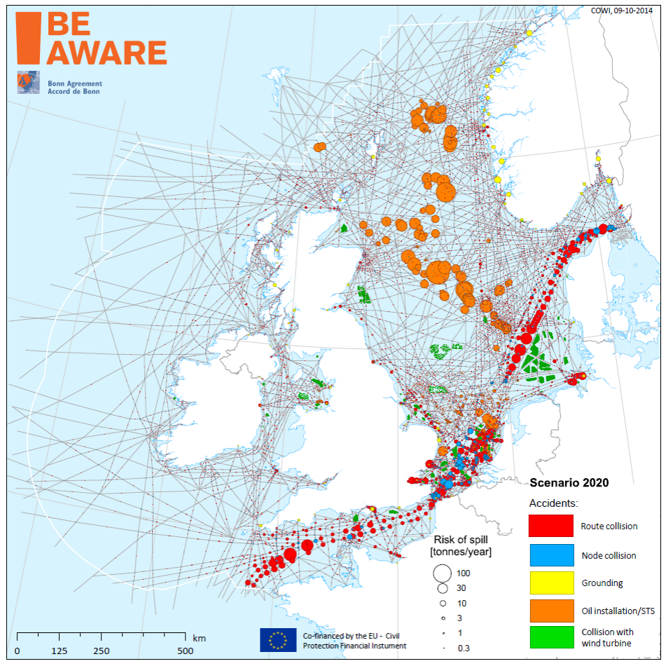

**Figure 2: Risk of all spills for 2020 in tonnes per year, i.e. a risk bubble of 100 tonnes/year could relate to a spill of 50000 tonnes with a return period of once every five hundred years.**

For the qualitative risk of HNS, the analysis focused on categorising the different hazards posed by the substances in terms of how they react when released in an accident, their risk to public health and their risk to the environment. The analysis again indicated that the main risks existed in the regions with the highest shipping density in the southern North Sea Channel area. The results also showed the spread of risk for HNS between those substances carried in bulk and those packed in containers as packed goods. This highlighted that higher levels than expected of HNS are transported as packed goods.

BE-AWARE II

The overall objective of BE-AWARE II is to model the outflow of oil from the spills predicted in BE-AWARE I for ten different response or risk reducing scenarios, taking into consideration the hydrodynamics of the North Sea Region. The model will then be combined with an analysis of the environmental and socioeconomic sensitivity of the region to assess the impact of the different scenarios. Based upon these and the cost of implementing the measures, risk management conclusions are developed for each of the 5 project sub-regions.

The methodology is outlined in the project Method Note and is based on the BRISK methodology but is modified to the specific North Sea conditions. The environmental and socioeconomic vulnerability analysis is based upon the methodology developed in BE-AWARE I. One of the main discussions during the development of the BE-AWARE II methodology was which future risk reduction and response scenarios should be included. Following discussion between the Project Partners the following scenarios were included: 1) Present situation (base scenario), 2) Future measures already planned for 2020 (future reference scenario), 3) Additional Vessel Traffic Services (VTS), 4) Additional Traffic Separation Schemes (TSS), 5) AIS Alarms (windfarms), 6) Implementation of E-Navigation, 7) New Emergency Towing Vessels (ETV’s), 8) Improved night detection capability, 9) Further use of dispersants and 10) 50% increase in response capabilities.

Oil spill/response modelling

In order to ascertain the fate and weathering of the oil for each future scenario multiple runs of the oil spill/response model will be undertaken. This will be carried out by modelling selected individual spill events using advanced numerical models, supported by analytical calculations. Based on this, key processes will be identified and parameterised into a simpler model for spill simulations.

The advantage of a simpler model is that it makes possible the large number of calculations (millions) that are required for the overall assessment. In this regard the modelling is different from traditional oil spill simulations in which advanced process models are applied to describe the effects of a single oil spill with high accuracy.

Thus the modelling includes a description of the spreading of the oil on the water surface, including releases from underwater, the drift by current and wind, as well as the decay of the oil. For light oil types the decay is simplified to describe only the evaporation while for heavy oils the decay is simplified to describe emulsification and natural removal from the surface. The model utilises the release points, spill sizes and types of oil identified in BEAWARE I.

In order to describe the effect of the emergency response to the oil spills in a practical manner in the model complex, the response methods are reduced to include the capacity of pumps and skimmers, as well as the equipment applied to convey the spill to the skimmers, e.g. booms attached to tow boats. The time lag for mobilising and transport from home port to spill position is included in the model. The effect of the emergency response is modelled as a reduction of the amount of oil in the oil slick.

In order to calculate the effect of the emergency response, an artificial model response is defined which replicates a possible and realistic emergency response. It is assumed that the response is carried out in three isolated actions at times T1, T2 and T3, so that the total response capacity increases with time, as more ships will reach the scene. The capacity for oil removal is calculated on the basis of the total number of ships on scene, oil skimmers and pumps, as well as the total length of booms that are available. In addition, the modelling contains a number of conditions which may reduce the effectiveness of the emergency response, such as visibility, darkness, limiting significant wave height etc.

Environmental and socioeconomic vulnerability analysis

The methodology for the environmental and socioeconomic vulnerability analysis developed in BE-AWARE I contains three distinct steps: STEP 1 – The identification of sensitive ecological and socio-economic features; STEP 2 – The vulnerability assessment and ranking of these features, based on a set of objective criteria and resulting in a seasonal vulnerability score for each feature: and STEP 3 – The total (seasonal) vulnerability mapping.

BE-AWARE I identified 49 features grouped into: shoreline and coastal habitats, open sea habitats, species, protected areas and economic features. In order to assess the vulnerability of these features a ranking workshop was held in Brussels in September 2014 where each environmental feature was given a seasonal ranking based upon the selected criteria and the economic features were given a single vulnerability ranking. From these ranking scores and the data collected by the project seasonal environmental vulnerability maps and an economic vulnerability map will be developed, which will then be combined into an overall vulnerability map for the region.

Impact Assessment

In order to assess the impact of each of the risk reducing and response scenarios the total amount of oil spilt, from the spills identified in BE-AWARE I, in tonnes spilt per meter squared per year (t/m2/year) and the total amount of oil spilt reaching the coast in tonnes per meter per year (t/m/year) will be calculated from the model. These will then be combined with the environmental and socioeconomic vulnerability analysis using a fine grid to provide a damage index which will be mapped for the region. Therefore by comparing each scenario against the reference scenario their impact can be assessed in terms of less oil spilt, less oil reaching the coast and a reduction in environmental and socioeconomic damage.

Risk Management Conclusions

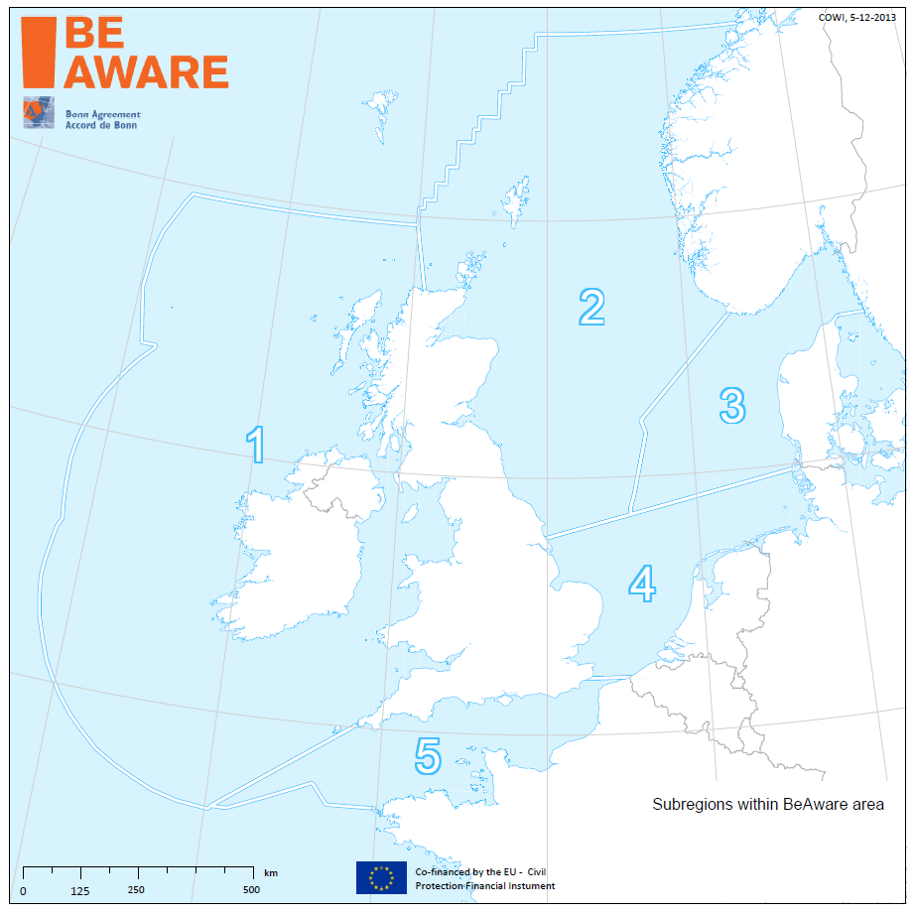The final aim of the project is to identify risk management conclusions for each of the BE-AWARE project sub regions. These conclusions will be based upon the effectiveness of the scenarios, as calculated in the impact assessment in terms of less oil spilt (t/y), and the efficiency of the scenarios, calculated in less oil spilt per cost (t/€).

These will then be plotted against each other in a scatter graph to identify the most suitable scenarios per sub region. The final risk management conclusions will be agreed by the Bonn Agreement Contracting Parties at a workshop in September 2015 and will be the critical output of the project.

**Figure 3: Be-Aware Project Sub -regions**